## **Model Outlining Summary**

Updated all models on 06/01/19

## **Overall summary of both data sets:**

## Reduced aggregation data Test_set_summary:

|  |  |  |  |  |  |
| --- | --- | --- | --- | --- | --- |
| **model** | **auc** | **f1** | **npv** | **precision** | **recall** |
| **RandomForestClassifier** | **0.75** | **0.49** | **90.02** | **0.34** | **0.9** |
| **LogisticRegression** | **0.75** | **0.49** | **89.33** | **0.33** | **0.9** |
| **XGBClassifier** | **0.76** | **0.50** | **89.97** | **0.34** | **0.9** |
| **SVC** | **0.75** | **0.49** | **89.39** | **0.33** | **0.9** |

## Clinical aggregation data Test_set_summary:

|  |  |  |  |  |  |
| --- | --- | --- | --- | --- | --- |
| **model** | **auc** | **f1** | **npv** | **precision** | **recall** |
| **RandomForestClassifier** | **0.79** | **0.53** | **91.64** | **0.37** | **0.9** |
| **LogisticRegression** | **0.77** | **0.52** | **91.16** | **0.36** | **0.9** |
| **XGBClassifier** | **0.80** | **0.55** | **92.58** | **0.40** | **0.9** |
| **SVC** | **0.77** | **0.51** | **90.76** | **0.36** | **0.9** |

With elixhauser:

|  |  |  |  |  |  |
| --- | --- | --- | --- | --- | --- |
| **model** | **auc** | **f1** | **npv** | **precision** | **recall** |
| **RandomForestClassifier** | **0.77** | **0.50** | **92.31** | **0.34** | **0.91** |
| **LogisticRegression** | **0.81** | **0.51** | **93.16** | **0.35** | **0.91** |
| **XGBClassifier** | **0.81** | **0.51** | **94.92** | **0.35** | **0.94** |
| **SVC** | **0.80** | **0.49** | **91.91** | **0.34** | **0.91** |
| **VotingClassifier** | **0.81** | **0.50** | **94.58** | **0.34** | **0.94** |
| **hard_voting_classifier** | **0.80** | **0.46** | **80.43** | **0.74** | **0.33** |

**48hr timewindow elix:**

|  |  |  |  |  |  |
| --- | --- | --- | --- | --- | --- |
| **model** | **auc** | **f1** | **npv** | **precision** | **recall** |
| **RandomForestClassifier** | **0.77** | **0.50** | **91.34** | **0.35** | **0.90** |
| **LogisticRegression** | **0.78** | **0.51** | **91.66** | **0.36** | **0.90** |
| **XGBClassifier** | **0.79** | **0.52** | **92.26** | **0.36** | **0.90** |
| **SVC** | **0.78** | **0.51** | **91.47** | **0.35** | **0.90** |
| **VotingClassifier** | **0.79** | **0.52** | **92.23** | **0.37** | **0.90** |
| **hard_voting_classifier** | **0.78** | **0.49** | **80.41** | **0.67** | **0.38** |

**24hr timewindow elix:**

|  |  |  |  |  |  |
| --- | --- | --- | --- | --- | --- |
| **model** | **auc** | **f1** | **npv** | **precision** | **recall** |
| **RandomForestClassifier** | 0.75 | 0.49 | 90.81 | 0.34 | 0.90 |
| **LogisticRegression** | 0.76 | 0.50 | 91.26 | 0.34 | 0.91 |
| **XGBClassifier** | 0.78 | 0.52 | 92.08 | 0.37 | 0.90 |
| **SVC** | 0.76 | 0.49 | 90.85 | 0.34 | 0.90 |

## **Detailed summary of both data sets:**

## **Reduced aggregation (Top 9 continuous aggregated + 4categorical +2 onetime measurements [2class])**

### Correlation (abs) of predictors

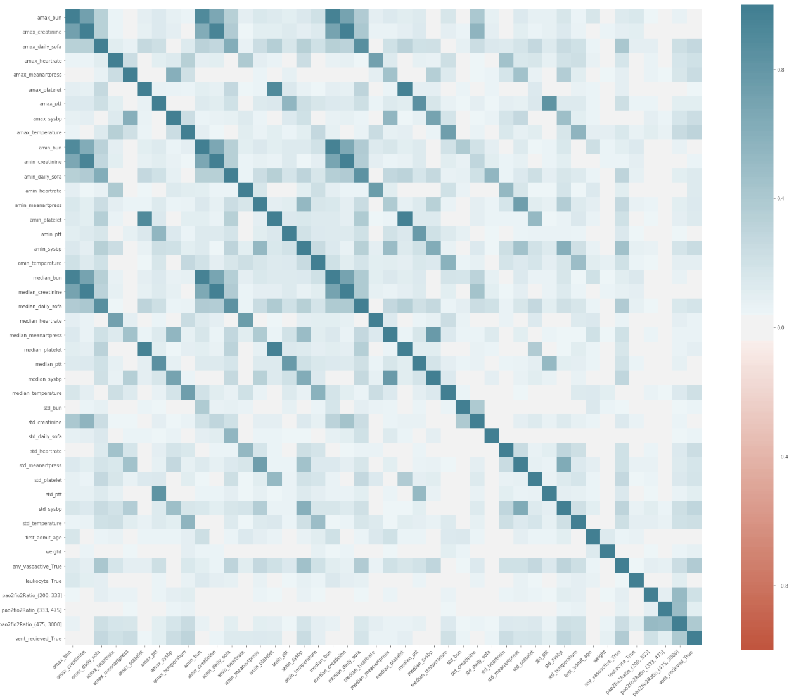

**Dropped one of the two predictors if corr>0.7.

## **Test_set_summary:**

### Svm

#### Test





### Xgboost

#### Test





#### Variable importance

median_temperature 0.041457

std_temperature 0.041552

pao2fio2Ratio_(475, 3000] 0.055144

amin_sysbp 0.084890

leukocyte_True 0.089784

median_daily_sofa 0.097590

dtype: float32

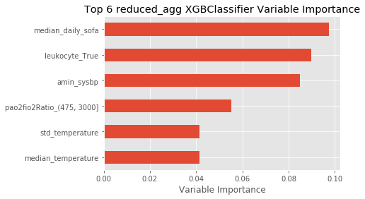

### RF

#### Test:





#### Variable importance

median_ptt 0.050922

std_sysbp 0.054353

std_daily_sofa 0.056248

std_temperature 0.077923

median_daily_sofa 0.077982

amin_sysbp 0.086021

dtype: float64

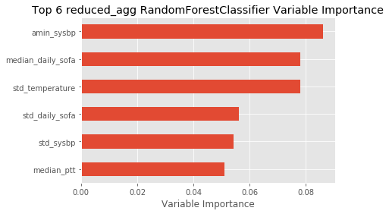

### Logistic Regression

#### Test





## **Clinically Guided Aggregation dataset**

### Correlation (abs) of Predictors

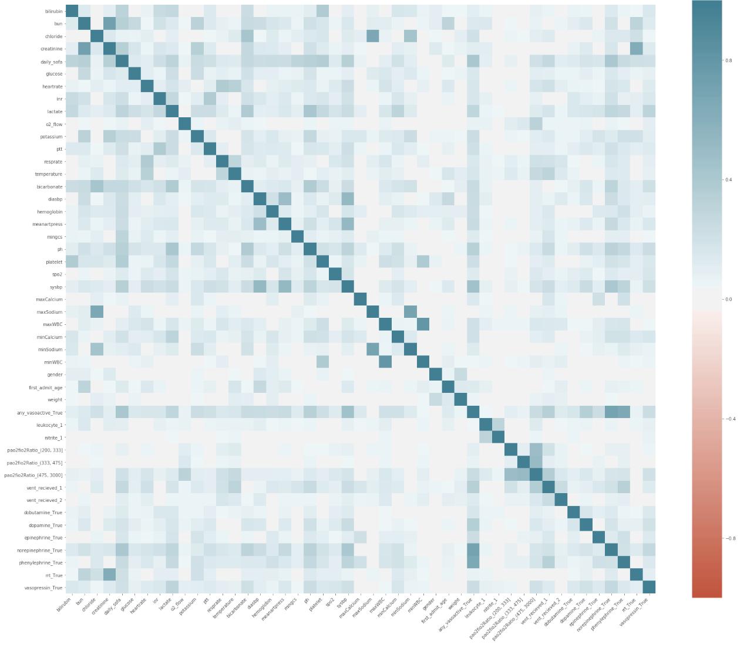

**Dropped one of the two predictors if corr>0.7.

### Svm

#### Test

### Xgboost

#### Test





#### Variable importance

bicarbonate 0.030492

temperature 0.035225

leukocyte_1 0.038087

ibands_absent 0.042682

daily_sofa 0.088163

norepinephrine_True 0.139670

dtype: float32

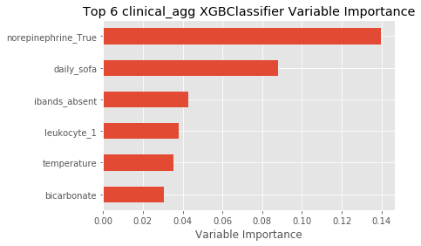

### RF

#### Test:





#### Variable importance:

norepinephrine_True 0.042131

resprate 0.045445

heartrate 0.048170

sysbp 0.057840

daily_sofa 0.063173

temperature 0.082495

dtype: float64

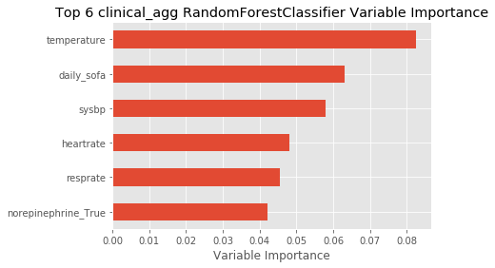

### Logistic Regression

#### Test





## **Local model (clinical agg)**

| **model** | **auc** | **f1** | **npv** | **precision** | **recall** |
| --- | --- | --- | --- | --- | --- |
| **local_xg_euc_50** | 0.73 | 0.49 | 89.08 | 0.33 | 0.9 |
| **local_lr_euc_50** | 0.67 | 0.45 | 84.12 | 0.30 | 0.9 |
| **local_xg_euc_100** | 0.75 | 0.51 | 90.49 | 0.35 | 0.9 |
| **local_lr_euc_100** | 0.69 | 0.46 | 86.34 | 0.31 | 0.9 |
| **local_xg_gow_50** | 0.67 | 0.45 | 83.02 | 0.30 | 0.9 |
| **local_lr_gow_50** | 0.63 | 0.43 | 77.93 | 0.29 | 0.9 |
| **local_xg_gow_100** | 0.70 | 0.47 | 86.80 | 0.32 | 0.9 |
| **local_lr_gow_100** | 0.65 | 0.43 | 78.20 | 0.29 | 0.9 |

### Local Xgboost

#### Local xg d=euc m=50





#### Local xg d=euc m=100





#### local xg d=gower m=50





#### local xg d=gower m=100





### Local Logistic Regression

#### local lr d=euc m=50





#### local lr d=euc m=100





#### local lr d=gower m=50





#### local lr d=gower m=100



